Creating the Welfare State
History AS / A Level: Lesson Ideas & Source Material
Draws on archive material displayed in the exhibition “A time for revolutions”: Making the Welfare State at LSE Library, January to April 2018 to provide original archive sources and supporting material around the 1942 Beveridge Report.

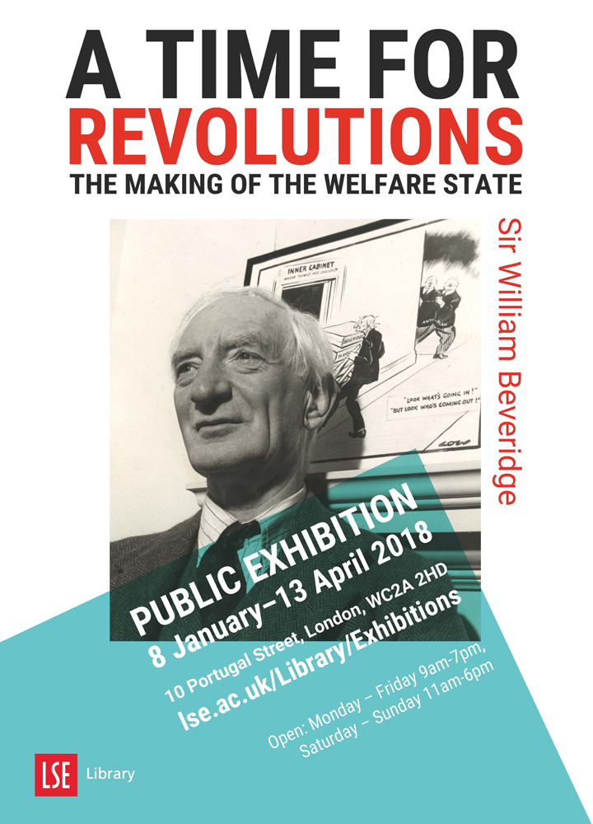

In December 1942 the government released a report authored by Sir William Beveridge in which he wrote “A revolutionary moment in the world's history is a time for revolutions, not for patching”. His report laid the foundations for Britain’s post war welfare state while the world was still at war. This resource is based on an exhibition that was held in the Library Gallery at the London School of Politics and Economics in January – April 2018 to mark the 75th anniversary of the publication of the Beveridge Report and the 70th anniversary of the Welfare State.
Images and textual evidence for this resource are taken from the heritage collections in the Library of the London School of Economics and Political Science (LSE). William Beveridge’s papers are held in LSE Library as are papers belonging to numerous politicians, activists and campaigning groups.
This is an open access resource under the terms of the Creative Commons Attribution-NonCommercial-ShareAlike 4.0 International (CC BY-NC-SA 4.0) License, which permits use, distribution and reproduction in any non-commercial medium, provided the original work is properly cited.
Transcripts and images of original documents are provided on the powerpoint slides and the teachers’ notes provide support contextual and background information. These resources can assist with learning activities around the understanding of causes and consequences, making links between different perspectives and awareness of the roles of different individuals, ideologies groups and ideas. References are made to the perspectives of historians writing on this area and finish with different historiographic approaches.
Supports aspects of the schemes of work for:
- Edexcel Paper 1, Option 1 H: Britain Transformed, 1918 – 1997. Theme 2: Creating a Welfare State
- AQA 1G Challenge and Transformation: Britain c. 1851 – 1964. The impact of the Second World War on British politics – The Labour Landslide of 1945 and Developments in social policy – the Beveridge Report
- AQA 2M Wars and Welfare: Britain in Transition, 1906 – 1957. Part Two. The Emergence of the affluent society; Section 2: the People’s War and Peace, 1939-1951. The social and cultural impact of ‘total’ war – the Blitz and plans for reconstruction.
The presentation and Teachers’ Notes for key stage 3 History (C) The creation of the Welfare State may also be of use for a general overview (scroll down here). The KS3 resources aim to introduce students to different forms of sources and applying analysis of evidence in preparation for GCSE specification, such as extracting data from charts or assessing at political posters. Definitions of key historical terms or events are given in the boxes, such as 'poverty' or 'Welfare State'.

The Beveridge Report and the Creation of the Welfare State (1941 – 1948)
Areas covered:
- Who was William Beveridge, his involvement in social welfare and why he led the committee
- The Beveridge Report, ‘the Five Giants’ and public impact
- What is meant by the welfare state and social security
- The influence of the Beveridge Report on the 1945 election – Conservative and Labour differences and similarities
- The implementation of the report under the Labour Government and how it led to the National Health Service

Beveridge & the Liberal Reforms of the 1900s
Background to Beveridge Slide
Flyer advertising Labour Exchanges, [Unknown], Beveridge/3/12
William Beveridge's involvement in social security pre-date his famous report. He played a key role in introducing a national system of labour exchanges in 1909 which helped to connect people seeking work with vacancies nationwide.
Beveridge's work on unemployment in the early twentieth century showed that unemployment had a structural cause and could only be solved by reshaping the demand for and supply of labour.
Alongside labour exchanges the Liberal government of 1906-14 passed other key reforms to provide a social safety net such as the Old Age Pensions Act (1908) and the first National Insurance Act (1911) which pooled money from workers, employers and government to provide financial assistance when unemployment hit.
There had been changes to the system of state benefits through the First World War, 1920s and 1930s, notably the use of a Means Test. Some historians have described Britain as having a ‘social service state’ prior to 1942; a patchwork of state funded resources, voluntary schemes and no support at all.
The welfare state is often spoken of as a triumph of peacetime, however, Beveridge's blueprint for it was drawn while the world was at war.
Why might Beveridge be equipped to deal with issues of infrastructure and reconstruction in 1942?
The Five Giants
Identifying the Five Giants
In June 1941 Beveridge was appointed to lead an interdepartmental committee, formed of members of the Civil Service, to recommend the redevelopment of British social services following the War. The final report was made available only eighteen months later after hundreds of hours of interviews and research had been carried out with businesses, trade unions, charities and other interested parties.
Among the most famous elements of the report were 'The Five Giants', personifications of the most pressing issues facing the country: want, squalor, ignorance, idleness, and disease. Beveridge sought to defeat these through redeveloped social services including, most famously, the National Health Service, family allowances and insurance to help people deal with periods of unemployment or other factors affecting employability, such as disability. The Five Giants depended on three ‘assumptions’ Beveridge argued must be in place to defeat them:
- Full (male) employment
- A national health system
- Child allowance
The ideas behind the Five Giants owe much to late 19th and early 20th social concerns, such as Charles Booth’s poverty maps and focus on ‘want’. What areas are needed to tackle each giant?
The Beveridge Report
Social Insurance and Allied Services: The Beveridge Report in Brief, 1942
On 1 December 1942, William Beveridge published a report that was officially called Social Insurance and Allied Services, but swiftly became known as the Beveridge Report. As one press report from the time stated it "became the discussion topic of the whole country, because if it is adopted by the Government and put into force it will revolutionize the whole life of the British people". It was a ‘personal’ report; that is it was signed by Beveridge rather than a government minister or department.
The report ‘envisages a future of state and citizen co-operation’ that partly came out of the collectivism brought by Total War (Pearce and Stewart, 2002). The report can be linked to changing attitudes brought by the impact of the Blitz on all classes, though arguably disproportionately those in the East End of London and poorer dock side dwellings in cities from September 1940. The exchange of population and sharing of accommodation between different classes and country and city people through evacuation from September 1939 practically illustrated differences in standards of living. The introduction of Free School Milk and Meals in 1941 was arguably a collective measure to improve living standards and a precursor to the reforms proposed by Beveridge. See Smith (2000) and Fraser (2003) for more on this.
Section of the Report in Brief on insurance – can print this out as a source for your students.
The Proposal
Guide to the Beveridge Plan, poster, 1943, Beveridge/11/39/8A. It is worth noting that the Social Security League, who produced this poster, was set up by Beveridge himself to make the case for the Beveridge Report.

Beveridge argued for an insurance system through which the citizen and business pays in and the state pays out. It is a universal system of social insurance financed by the state with contributions made by employers and employees from their pay. Beveridge promoted a flat-rate basic (subsistence) payment to protect people not working through sickness, unemployment or old age. This took people of means tested forms of benefits [can refer back to the ‘Hungry Thirties’] and made benefits an entitlement, a form of social contract between citizen and state.
The insurance would be taken from pay at a flat tax rate across all pay (Income Tax rate was far higher in 1940s but less people earnt enough to pay it than now). It was a minimum income for subsistence to prevent Want but discourage Idleness, i.e. the incentive was to work. It was not an earnings-related benefit as some parts of Europe had (have).

There was a commitment to full male employment for the proposals to work so enough money came from employee and employer to the government. The employment of men was presumed. This created a number of problems for women who, if married, were assumed to have a wage earner supporting them restricting their access to full benefits and limiting their options for work (Timmins, 2017). There was a set rate for employed and unemployed recipients of the Family Allowance so the unemployed would not benefit more if they had a lot of children and would still earn more by being in work.
[You could print this slide out for the class as an exercise.]
Impact and Reception
Telegram from Buckingham Palace to Sir William Beveridge, 1942, Beveridge/SIC/5
Over 650,000 copies of the report were sold, a startlingly high number for a government document. It also attracted much press attention both in the UK and worldwide. Beveridge, to the consternation of civil servants and much of the coalition cabinet, had leaked the report’s content before publication to fuel public interest in it. Beveridge also received letters from members of the public and those involved in the war-effort whether at home or in the field. Many were grateful for plans for a more equal post-War society and hopeful for their implementation after years of loss and austerity.
The idea of national insurance against unemployment helped give meaning to what people fighting for in the Second World War. Public opinion polled by British Institute of Public Opinion (BIPO) and published in the News Chronicle showed that 86% of the British public were in favour of the measures listed in the Beveridge Report, 6% against, 8% unknown or undecided. Can discuss why received so well using telegram, poem and letter on slides and below:
Letter to William Beveridge from Albert E. Opie

Beveridge / 9A / 39

No. 12 Wellington Street, Plymouth, Devon

Dear Sir,
Would you be so kind, to Accept these few verses composed by An Old Age Pensioner and wishing you every success, in your Fight for Liberalism.
Sincerely yours,
Albert E. Opie

'Memories of Sir William Beveridge' By Albert E. Opie

At last, there is A Saint on Earth, An angel he would be if only he could have his Will and make the commons Pass his Bill.
It Aim's at all that is so good, but not so say's Sir Kingsley Wood the Nation cannot bear the Strain so all appeals they are in Vain.
And to the Boys that’s gone to fight, that they should see A shining Light, when Poverty and Want no more will ever reign on Britain's Shore's
The Beveridge Plan is good and just, so one Day I am sure it must, find its Name on the Scroll of Time to A Gentleman called Beveridge by Name.

Letter to William Beveridge from Capt P.D.J. Druiff

Beveridge / SIC / 5

December 8 1942 Capt. P.D.S Druiff
M.I., G.H.Q, Middle East Forces

Dear Sir William,
Just a line to wish you the compliments of the Season and to hope that you are keeping fit in spite of all your arduous public work.

The local English press has made a big splash about your great scheme for social security after the war and has devoted at least two issues to it. It really is a magnificent plan, if I may say so, and all the soldiers with whom I have discussed it have taken a keen interest in the proposals. If only the Government at an early stage would announce that they accept your proposals as the basis of their legislative programme, it would do untold good from the morale point of view out here alone.
Hitherto in discussions about the post war world with all circles of the military the xxx attitude is that England will be a played-out country and that the future will be with the United States and possibly the Dominions. They often say "they are not returning home to be taxed out of existence". It seems to me that such an attitude being so commonly held will in itself create those evils, if they did not exist already. Now if your plan can, as it seems to be doing, dissipate the feeling of post war pessimism that alone will be of the greatest service.

At the moment I am with a Field Formation far from the front but I saw some action at Alamein. I met Maurice Allen of Balliol in Cairo and he wishes to be kindly remembered to you. He is in the Ciphers Dept. Of GHQ, very happy and is by now in India.

Wish you all good wishes,
Sincerely
Phillip D.J. Druiff

Beveridge as Communicator

Beveridge was a well-known academic and civil servant. He used popular methods of communicating, such as radio during the 1930s and knew influential people. A talk by Beveridge was broadcast by BBC on the radio on 2 December 1942 in translated into 22 different languages. He also gave an interview to the newsreel Pathe Gazette. Copies of the report were circulated to troops and dropped in parts of occupied Europe.

In this radio broadcast, only days after the report is published, Beveridge explains his radical plans for economic and social reform in post-war Britain. He argued we need ‘the abolition of want before the enjoyment of comfort’.
This broadcast is still available if you can get adobe flash to work the BBC Archive Website. It is 15 minutes long: http://www.bbc.co.uk/archive/nhs/5139.shtml
In addition the Pathe Gazette clip is 2 minutes long and on You Tube. It is free for non-commercial use:
https://www.youtube.com/watch?v=l2DhvTCuK_s
Use of the Beveridge Report

The term Welfare State was first used by the Archbishop of York, William Temple, in 1941. He was Archbishop of Canterbury from 1942 and close friends with Beveridge, though Beveridge himself preferred the term ‘social security’. Temple used it to describe a system of state support with contributions from all working people to look after the welfare of the nation and its people. The idea of the Welfare State was only gradually established. The term Social Security as a State-run form of assistance was only adopted in 1950 by Labour Prime Minister (and leader) Clement Attlee for Labour’s General Election campaign. (Timmins, 2017).

All forms of voluntary and charitable support, including hospitals and nursing homes, were defined as social services. The Beveridge Report was according to Bernard Harris a ‘complex mixture of Edwardian liberalism and wartime collectivism, and it adopted an essentially gradualist approach to social change’ (Harris, 2004: 290).

Ultimately the inclusion of the use of voluntary or ‘friendly societies’ was not included in the practical enactment of the report by the Labour Government

Politicians were united on the need to change the system of social care but divided on how to make it work and how much of the Beveridge Report to put into practice.

1945 Election

1945 The Voters Guide (Rushworth / 5)

The Labour Party embraced the Beveridge Report but put the emphasis on increased state intervention rather than the use of voluntary societies. Some Labour MPs tried to get a vote through parliament to endorse the report in in February 1943 as a result a further committee was formed to look in detail at implementing the recommendations of the report (the Sheepshanks Committee) in April. In the Labour Party Manifesto published before the 1945 election, the implementation of the recommendations around national insurance and health is at the centre of its election promises. Key senior Labour politicians had also run some of the most relevant domestic departments during the war, such as Ernest Bevin, Minister of Labour and National Service.

The Conservatives agreed with aspects of the report. Churchill coined the phrase 'From the Cradle to the Grave' in a radio broadcast in March 1943 to describe the need for some form of social insurance and security of every class of citizen in the state. There was still a prevailing feeling against state intervention and for ‘freedom of choice’, particularly in health care, in much of the Conservative Party. The Tory Reform Group – a group within the party – argued for more of a social consensus in accepting the main provisions of the report.

By the time of the War's end and the 1945 general election campaign, the groundswell of popular support for the redistributive ideas was such that even Conservative politicians were either showing outward support for them or, at least, not arguing against them.

This ‘Voters’ Guide’ by Harold Storey on the slide is titled ‘an impartial political survey’, yet, arguably the paragraph quoted on the slide indicates bias. Can your students identify that bias? [Give the context of Churchill ‘gestapo’ speech about Labour on 4 June 1945, which went down badly in public opinion].

The General Election took place on 5 July 1945 but the results were not all counted until 26 July due to the need to collect votes from an enormous number of men and women voting in armed services that were stationed across the world.

The next 6 slides give examples of how the Beveridge Report was used or referred to (sometimes obliquely) by candidates from manifestos and campaign literature belonging to the three main political parties in the UK at the time of the 1945 General Election. This can support work using primary sources on the impact of the Beveridge Report and / or the 1945 General Election.

Liberals

Photograph of ‘Liberal candidate’ William Beveridge with Liberal Party candidate Frank Byers (later Baron Byers) and Joan Byers from his campaign leaflet for the 1945 General Election. (Josephy / 5)

William Beveridge, having not publicly supported a political party before, entered parliament as Liberal MP for Berwick on Tweed in 1944 but lost his seat to a Conservative candidate in the 1945 election. He later became a Baron and led the Liberal Party in the House of Lords.

Frank Byers was elected for the Liberals in the North Dorset Constituency in 1945. He was one of only 12 Liberal candidates elected to the House of Commons.
From Byers’ Liberal Manifesto leaflet for the 1945 election:

Real Social Security in Full
The Liberal Party has the best record for Social Reform and wants Social Security in full, which means that every man and woman in Britain, on conditions of working when they can, and contributing from their earnings, shall have an income as a right, when for any reason they cannot work. This income must be sufficient for the needs of themselves and their families. The Beveridge Report means this. The Conservative Proposals on National Insurance do not.

Election Manifesto of Frank Byers (Liberal), 1945.

This draws on Beveridge but also refers to the 1900s social reforms of the Liberal government.

Conservative

Charles Challen was MP for Hampstead in London 1941 – 1950 and this is his Manifesto for the 1945 General Election.

Detail - Health

His support for restricting state role in health and supporting the ‘independence’ of the medical profession, i.e. not having a National Health Service for which all doctors work is detailed here:

Health - In making the Health Services of the country available to all, it is important to remember that progress depends on the skill and initiative of the various classes of professional people concerned. Healing demands confidence between patient and healer. We must see to it that, whatever kind of regulation by the authorities of the State may be necessary to secure greater facilities for proper treatment, we do not sacrifice professional principles and traditions of profound value. It should go without saying that I am in favour of maintaining the patient’s free choice of doctor.

Election Manifesto of Charles Challen (Conservative), 1945 (Finsberg / 10/ 1)

Divisions? The Tory Reform Group

Some Conservatives supported the Beveridge Report more fully, such as members of the Tory Reform Group who wanted a chance from traditional conservativism and support state intervention in social matters. This group argued for cross party ‘social consensus’. Hugh Molson was MP for Doncaster 1931-35 and for High Peak, Derbyshire 1939-61. He was a member of the Tory Reform Group as this section of his manifesto makes clear:

Beveridge Report
I was one of those forty-one Conservatives, the nucleus of the Tory Reform Committee, who came out at the beginning as a strong supporter of the principles of the Beveridge Report and I put my name to an Amendment asking that immediate steps be taken to put it into effect.

Election manifesto of Hugh Molson (Conservative), 1945 (Coll Misc/0723)

Labour

Labour Party Pamphlet, 1945 (Dalton / 2 / 7)

Text opposite the cartoon:
You are the people in the cartoon asking to be served and you are entitled to ask for the fulfilment of pledges made to you by all the parties. Your job is to decide which party, which candidate, in this election, is most likely to deliver the goods.

Labour

Back of same pamphlet / poster. [Note use of ‘total war’.]
Ask students: Can you identify the ‘Five Giants’ in the Labour poster?

The 1945 election led to a Labour Party landslide with over 100 MPs more than any other party. The Labour government introduced the steps for the National Health Service (NHS) and the implementation of other areas identified within the Beveridge Report, such as national insurance.

The years following 1945 were known as a time of post-War consensus: a tacit agreement by the main political parties (publically at least) that the Beveridge welfare state and mixed economy would best keep inequality in check.

Steps to the creation of the Welfare State and NHS

1945 Family Allowances Act
1946 National Insurance Act & National Health Services Act
1946 USA 50 year loan to UK of $3.75 Billion
5 July 1948 National Health Service established

Further Reading

As well as works cited this list assist with covering some areas on the historiography of the Welfare State. For example, Harris (2004: 8-13) on positioning the welfare state within a post-structuralist context drawing on Michel Foucault’s ideas of ‘social control and surveillance’.

Charles Booth's poverty maps and contextual information from the 1900s can be found as digital content on the LSE website Charles Booth's London:
https://booth.lse.ac.uk/

Derek Fraser (2017), The Evolution of the British Welfare state. A History of Social Policy since the Industrial Revolution, Basingstoke: Palgrave, Macmillan
Bernard Harris (2004), The Origins of the British Welfare State. Social Welfare in England and Wales, 1800 – 1945. Basingstoke: Palgrave, Macmillan
Kevin Jefferys (ed.) (1994), War and Reform. British Politics during the Second World War, Manchester: Manchester University Press
Malcolm Pearce and Geoffrey Stewart (2002), British Political History 1867 – 2001. Democracy and Decline. London: Routledge
Malcolm Smith (2000), Britain and 1940. History, myth and popular memory, London: Routledge
Nicholas Timmins (2017), The Five Giants. A Biography of the Welfare State, London: William Collins

